DATA TRANSFORMATION

Objective:
The goal of this phase was to take the raw/generated data and reshape it into a clean, analysis-ready format. Transformation taken involved:
- Ensuring consistent structure
- Renaming columns for clarity
- Reshaping or joining data as needed

Tools & Environment:
- IDE: Visual Studio Code (VS Code)
- Language: Python
- Libraries Used: pandas, numpy, datetime

Transformation Activity:
- Check data types and apply conversions as needed
- Rename columns using lower case formatting.
- Replace inconsistent values to ensure row-level consistency.
- Handle null values by filling them based on agreed upon rules.

Limitations:
- The data is synthetic and does not reflect actual values related to company performance.
- There were minimal transformations applied in this project, as the data was intentionally generated in good condition for project purposes.

Transformation Workflow:
- Load Raw Data:
- Loaded the raw csv files generated from the data creation phase
import pandas as pd
import numpy as np

cutomers = pd.read_csv('customers.csv')
travel_package = pd.read_csv('travel_package.csv')
travel_guide = pd.read_csv('travel_guide.csv')
sales = pd.read_csv('sales.csv')
feedback = pd.read_csv('feedback.csv')
refund = pd.read_csv('refund.csv')

- Customers Table:
- Clean ‘email’ column by replacing values
- Fill the null values with ‘not_provided’
# 1. customers table
# clean up the email column
customers['email'] = customers['email'].str.replace(',','').str.replace('..','.')
customers.isna().sum()

# fill na email with 'not provided'
customers['email'] = customers['email'].fillna('not_provided')

# Sample Final Output:
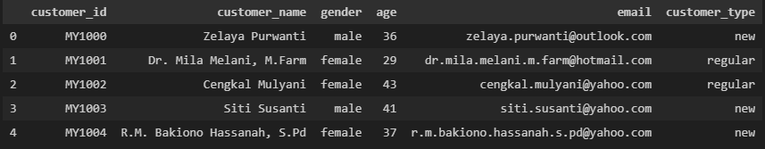
- Feedback Table:
- feedback_date column is converted from string to date data type.
# 2. feedback table

feedback.dtypes

feedback['feedback_date'] = pd.to_datetime(feedback['feedback_date'])
feedback.head()

# Sample Final Output
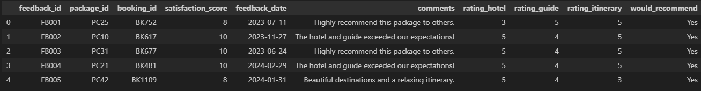
- Refund Table:
- refund_date column is converted from string to date data type.
refund['refund_date'] = pd.to_datetime(refund['refund_date'])
refund.dtypes

# Sample Final Output:
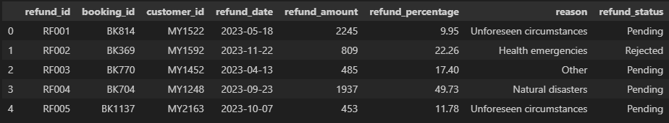

- Travle Guide Table:
- Clean ‘role’ column by replacing values
# 4. travel_guide table

travel_guide['role'] = travel_guide['role'].str.replace('_', ' ')
travel_guide.head()

# Sample Final Output:
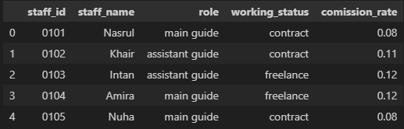

- Travel Package Table:
- No transformation done.
# Sample Final Output:
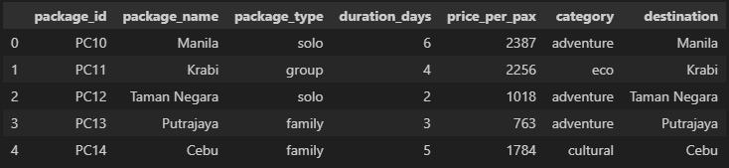

- Sales Table:
- Clean ‘payment_method’ column by replacing values
sales['payment_method'] = sales['payment_method'].str.replace('_', ' ')
sales.head()

# Sample Final Output:
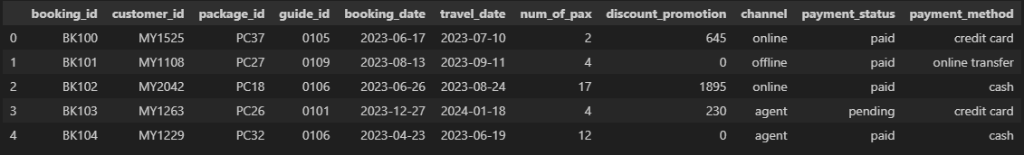

- Saving Outputs: “path: End To End Project/PPNJ/data creation”
# Saving all csv files
customers.to_csv(r"C:\Users\User\Desktop\Data Analyst\End To End Project\PPNJ\data_creation\dim_customer.csv", index=False)

travel_package.to_csv(r"C:\Users\User\Desktop\Data Analyst\End To End Project\PPNJ\data_creation\dim_travel_package.csv", index=False)

sales.to_csv(r"C:\Users\User\Desktop\Data Analyst\End To End Project\PPNJ\data_creation\fact_sales.csv", index=False)
feedback.to_csv(r"C:\Users\User\Desktop\Data Analyst\End To End Project\PPNJ\data_creation\dim_feedback.csv", index=False)

travel_guide.to_csv(r"C:\Users\User\Desktop\Data Analyst\End To End Project\PPNJ\data_creation\dim_travel_guide.csv", index=False)

refund.to_csv(r"C:\Users\User\Desktop\Data Analyst\End To End Project\PPNJ\data_creation\dim_refund.csv", index=False)

Summary of Transformations:
https://github.com/nasrulkhair/Full-Project/blob/main/PPNJ/data_creation/data.ipynb
- All transformations were done programmatically using pandas to ensure reproducibility.
- Output is clean, schema-consistent, and ready for further modelling
No. | Table | Column | Transformation
 | customers | email | fill null values with ‘nor provided’
 | customers | email | replacement:  , ‘’ / ‘..’ ‘.’
 | feedback | feedback_date | convert data type from STRING to DATE
 | refund | refund_date | convert data type from STRING to DATE
 | travel_guide | role | ‘_’ ‘ ‘
 | sales | payment_method | replace ‘_’ ‘ ‘

